Friday, November 11, 2022
NOTICE OF THE ANNUAL GENERAL MEETING

Dear Old Dalian,

The Annual General Meeting of the Association is to be held at the Dhirubhai Ambani Auditorium, Daly College Indore on Sunday December 11th, 2022 at 11:30 am followed by Principal’s Lunch at Harish Chandhok Lawns, New Guest House, Daly College.

Following are the Agenda for the A.G.M. :
- To approve the minutes of the last A.G.M and the Adjourned AGM.
- Hon. Secretary’s Report
- To take on record and pass the accounts for the year 2021-2022.
- To decide the amount for holding an EOGM.
- To appoint an auditor and fix his remuneration.
- Any other matter with the permission of the chair.

Please make it convenient to attend the A.G.M.

Thanking you,
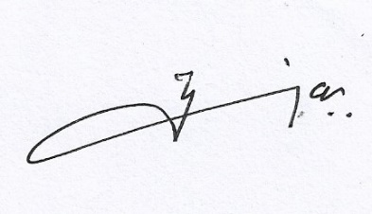
Yours sincerely,

Tejvir Juneja
(Hon. Secretary)
+919827032052

