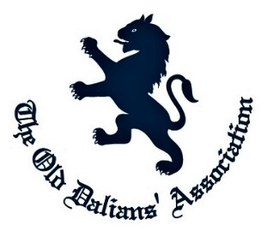
The Old Dalians’ Association
The Daly College, Indore -452001
Phone: +917312719010 | Mob. +91 9039123111
Website: www.olddalians.org| E-mail: oda.executive@gmail.com
Reg. No. 03/27/01/19643/17

NOTICE FOR EXTRA ORDINARY GENERAL MEETING

Monday, January 23, 2023
Dear members,
Pursuant to receipt of notice for requisitioning Extra Ordinary General Meeting (as attached), an Extra Ordinary General Meeting of the Association shall be convened on Sunday, 12th day of February, 2023 at 12 noon at the DBA Auditorium, Daly College, Indore to consider the following agenda:
- “To resolve to strike off resolution No. 3 of AGM dt. 31st July 2022 to the extent of imposing punishment of suspension of membership of Prateek Modi for a period of one year and him not being allowed to hold any position in the ODA forever.”
Please note that 100 members shall form a quorum for the extraordinary general meeting.
Please make it convenient to attend the meeting.

Thanking you,
For The Old Dalians’ Association,

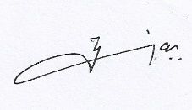
Hon. Secretary
(Tejvir Juneja)
ATTACHED: - NOTICE DATED 09-01-2023 FOR REQUISITIONING EXTRA ORDINERY GENERAL MEETING OF THE OLD DALIANS ASSOCIATION

